UNIVERSITY OF SPLIT
FACULTY OF ELECTRICAL ENGINEERING, MECHANICAL ENGINEERING AND NAVAL ARCHITECTURE

MASTER THESIS

WEB APPLICATION FOR SOCIAL NETWORKING OF ERASMUS STUDENTS

Adriana Protrka

Split, month year.
 | UNIVERSITY OF SPLIT  FACULTY OF ELECTRICAL ENGINEERING, MECHANICAL ENGINERING AND NAVAL ARCHITECTURE | 

Graduate university study: Naziv studija
Program module: Naziv smjera/usmjerenja
Program code: 210
Academic year: 2023./2024.

Name and surname: ADRIANA PROTRKA
ID number: xxx-xxxx

MASTER THESIS ASSIGNMENT

Title: WEB APPLICATION FOR SOCIAL NETWORKING OF ERASMUS STUDENTS

Task: Study the principles of creating a web application using modern technologies with a special emphasis on the Yii programming framework and the php programming language. Study the possibilities of integration with the database and choose the appropriate technology for the realization of the web application. Learn client technologies suitable for integration with the Yii development framework. To design a data model on outgoing Erasmus mobilities available to students of the University of Split. Enable interactive viewing of stored data and user addition of data to registered users. Design a clear interface. Realize and test the web application.

Thesis Submitted:

Chairman of the  Examining Board: |  | Supervisor:
Ime Prezime, PhD, Full Professor |  | Ime Prezime, PhD, Assistant Professor

ABSTRACT

Introduction
The rise of globalization and increased mobility has resulted in a notable surge in the count of international students taking part in exchange programs. For Erasmus students, forming connections and engaging socially with fellow students holds immense importance during their time abroad. Given the widespread use of social networking platforms, there arises a necessity for a tailored platform that caters specifically to the distinctive requirements of Erasmus students.

The objective of this master's thesis is to create a web application that focuses on social networking and is exclusively designed for Erasmus students studying at the University of Split. The thesis will explore the principles of modern web application development, with a particular emphasis on the Yii programming framework and PHP programming language. It will examine the options for integrating the web application with a database and selecting appropriate client technologies for integration with the Yii programming framework. Furthermore, the thesis will focus on designing a data model for outgoing Erasmus mobility programs available to students of the University of Split, enabling interactive data browsing and user data addition. Additionally, the thesis will cover designing a clear user interface, followed by implementing and testing the web application.

Through the completion of this thesis, the aim is to provide a practical solution for the social networking needs of Erasmus students and demonstrate the applicability of modern web application development principles in the creation of specialized platforms.

Motivation

The reasons behind choosing a Master's thesis on the subject of a web application for social networking among Erasmus students are manifold.

Firstly, such an application holds the potential to foster connections, facilitate information exchange, and foster the formation of friendships among students. This, in turn, can have a positive impact on their academic and social experiences throughout their Erasmus journey.

Secondly, the development of such an application utilizing contemporary technologies like the Yii framework and the PHP programming language presents captivating prospects for students to deepen their comprehension of web development principles, data modeling, database integration, and user interface design. Gaining mastery over these technologies can also lead to enticing career opportunities across various industries.

Therefore, in order to construct a web application that caters specifically to the distinctive needs of Erasmus students, it is crucial to address pivotal research inquiries such as:

- What are the key principles of developing a web application using modern technologies with a focus on the Yii framework and PHP programming language?
- What are the various options for integrating a web application with a database, and how do they compare in terms of performance, scalability, and security?
- How can client-side technologies be integrated with the Yii framework to provide a rich user experience for web application users?
- What are the essential components of a data model for tracking outbound Erasmus mobility opportunities available to students at the University of Split, and how can they be represented in a web application?
- How can web application developers ensure that the user interface of their applications is intuitive, responsive, and easy to use, even for users with limited technical expertise?
- What best practices should be followed when testing a web application built with the Yii framework and PHP, and how can these practices be implemented effectively?
- How can security vulnerabilities be identified and addressed in a web application built with the Yii framework and PHP, and what are some common attack vectors that developers should be aware of?

Answering these questions will provide valuable insights into developing a web application for social networking among Erasmus students that is both functional and secure.

State of the Art
This section provides a comprehensive overview of the latest research and advancements in web development technologies that are currently available and relevant to the scope of this study.

1.2.1 Programming Languages for Web Development
The field of web development has witnessed significant transformations in the programming languages used, driven by the evolving requirements of modern web applications and websites. Here, we explore some of the prominent programming languages in this domain and their current state of the art:

- PHP: PHP, a server-side language with a longstanding presence of more than two decades, continues to be widely utilized today. Renowned for its user-friendly nature and seamless integration with databases like MySQL, PHP frameworks such as Yii, Laravel, and Symfony have gained popularity among developers.

- JavaScript: JavaScript is the most widely used language for web development, and its popularity continues to grow. With the rise of front-end frameworks like React, Angular, and Vue.js, JavaScript has become even more powerful. It is also used for server-side development with Node.js.
-TypeScript is a superset of JavaScript that adds static typing and other advanced features to the language.

- Python: Python is another popular language for web development, especially for back-end development. It is known for its simplicity, readability, and scalability. Python frameworks like Django and Flask are widely used for building web applications.

- Ruby: Ruby is an open-source and dynamic programming language that boasts an easily readable and writable syntax. It finds extensive usage in web development, particularly when paired with the Ruby on Rails framework.

- C#: C#, developed by Microsoft, is a versatile language applicable to various domains, including web development. It finds particular usage in back-end web development with frameworks like ASP.NET.

By providing this comprehensive overview, it becomes evident that the selection of a programming language in web development is influenced by factors such as user-friendliness, integration capabilities, scalability, and security.

PHP frameworks
PHP is a popular server-side programming language for web development. Here are some of the most popular PHP frameworks used today:

- Yii: Yii is a fast, secure, and high-performance PHP framework that is suitable for building large-scale web applications. It offers features such as a powerful Model-View-Controller (MVC) architecture, built-in security features, and excellent caching support.

- Laravel: Laravel is a free, open-source PHP web framework and widely considered the best PHP framework for web application development. It offers features such as easy database migration, task scheduling, unit testing, and more. Laravel is highly customizable and scalable, making it ideal for building complex web applications.

- Symfony: Symfony is a high-performance PHP web framework that offers a modular architecture, allowing developers to choose the components they need for their specific project requirements. It also includes built-in security features, such as user authentication and authorization, making it a popular choice for enterprise-level web applications.

- CodeIgniter: CodeIgniter is a lightweight, easy-to-learn PHP framework that is suitable for building small to medium-sized web applications. It offers features such as a simple, intuitive interface, a powerful Model-View-Controller (MVC) architecture, and excellent documentation.

- CakePHP: CakePHP is a rapid development PHP framework that provides a powerful set of tools for building web applications. It offers features such as scaffolding, which generates basic CRUD functionality for the application's database, as well as easy database migration and testing.

- Zend Framework: Zend Framework is a powerful and flexible PHP framework that is suitable for building large, enterprise-level web applications. It offers features such as a modular architecture, support for multiple database systems, and a powerful object-oriented programming model.

Databases
Here are some of the most popular databases used with PHP:

- MySQL: MySQL is a free and open-source relational database management system that is widely used with PHP. It is known for its scalability, high-performance, and ease of use. It supports multiple storage engines, including InnoDB, MyISAM, and others, and can be easily integrated with other technologies like Apache and PHP.

- PostgreSQL: PostgreSQL is a powerful, open-source relational database management system that is known for its advanced features, including support for complex queries, transactions, and concurrency control. It is highly scalable and can handle large databases with ease. It is often used for web applications that require complex data structures and high-level security.

- MongoDB: MongoDB is a popular NoSQL database that is designed for scalability and flexibility. It uses a document-based data model that allows developers to store data in a more natural way, making it easier to work with complex data structures. It is often used for web applications that require high-speed data access and scalability.

- SQLite: SQLite is a lightweight, serverless, and self-contained database that is often used for small to medium-sized web applications. It requires no installation or configuration and can be easily embedded into a PHP application. It is known for its simplicity, reliability, and ease of use.

- Oracle: Oracle is a popular commercial relational database management system that is often used for large enterprise-level web applications. It offers advanced features such as support for high-level security, scalability, and availability. It can also handle large amounts of data with ease and provides excellent performance.

- Microsoft SQL Server: Microsoft SQL Server is a relational database management system that is widely used for web applications on the Windows platform. It offers a wide range of features such as support for business intelligence, data analysis, and reporting. It is highly scalable and can handle large databases with ease.

Web servers
Those are some of the most popular web servers used in modern web development:

- Apache HTTP Server: Apache is the most widely used web server in the world, with over 40% of websites using it. It is an open-source web server that runs on a variety of operating systems, including Linux, Windows, and macOS. Apache is highly configurable, modular, and supports a wide range of programming languages and technologies.

- Nginx: Nginx is a popular open-source web server and reverse proxy server. It is known for its high performance, scalability, and ability to handle large amounts of traffic. Nginx is often used in conjunction with Apache, serving as a proxy server to handle static content and offloading some of the load from Apache.

- Microsoft IIS: Internet Information Services (IIS) is a web server developed by Microsoft. It is designed to run on the Windows operating system and is tightly integrated with other Microsoft technologies such as ASP.NET and Microsoft SQL Server. IIS supports a variety of protocols, including HTTP, HTTPS, FTP, SMTP, and NNTP.

- Lighttpd: Lighttpd is a lightweight, open-source web server designed for high-performance environments. It is optimized for handling a large number of simultaneous connections, making it ideal for serving static files and handling high-traffic websites.

- Caddy: Caddy is a modern, open-source web server that is designed to be easy to use and highly configurable. It includes built-in support for HTTPS, HTTP/2, and automatic SSL certificate generation. Caddy is often used for serving static websites, but it can also handle dynamic content and proxy requests to other servers.

- Node.js: Node.js is not a traditional web server, but rather a platform for building server-side applications using JavaScript. It is based on the V8 JavaScript engine developed by Google and is known for its high performance and scalability. Node.js is often used for building real-time applications and APIs.

1.2.5. Protocols in web development
Protocols are a set of rules that define the format and transmission of data between different systems. In web development, protocols play a crucial role in facilitating communication between servers and clients. Here are some of the most important protocols used in web development:

- Hypertext Transfer Protocol (HTTP): HTTP is the primary protocol used for communication between web clients (such as browsers) and web servers. It defines how requests and responses should be formatted and transmitted, and is responsible for facilitating the exchange of information between the client and server.

- Secure Sockets Layer (SSL)/Transport Layer Security (TLS): SSL/TLS are protocols used for encrypting data transmitted over the internet, providing secure communication between clients and servers. SSL/TLS is commonly used to secure HTTP traffic, resulting in HTTPS (HTTP Secure).

- File Transfer Protocol (FTP): FTP is a protocol used for transferring files over the internet. It is commonly used by web developers to upload website files to a web server.

- Simple Mail Transfer Protocol (SMTP): SMTP is a protocol used for sending email messages over the internet. It is commonly used by web developers to send automated email messages from a website.

- Domain Name System (DNS): DNS is a protocol used for resolving domain names (such as www.example.com) into IP addresses. It is responsible for translating human-readable domain names into machine-readable IP addresses that computers can use to locate web servers.

These protocols play a vital role in web development and are essential for facilitating communication between different systems on the internet.

Theory

Web development concept

MVC arhitecture pattern
Model–view–controller (MVC) is a software design pattern commonly used for developing user interfaces that divides the related program logic into three interconnected elements. This is done to separate internal representations of information from the ways information is presented to and accepted from the user.

Even though MVC is known as design pattern, we may be wrong if we refer it only as a design pattern because design patterns are used to solve a specific technical problem, whereas architecture pattern is used for solving architectural problems, so it affects the entire architecture of our application.

It has three main components that interacts with each other: Model, View and Controller [Figure 2.1.1.]. Each of them has very different and important role in the arhitecture pattern.

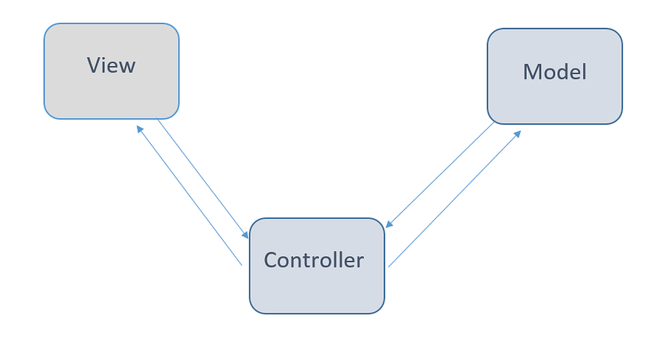
Figure 2.1.1. Relationships of three main components

- Model
Model is the lowest level of architecture. It implements the logic for the application’s data domain and defines the components of the app.
For example, if you are creating a Social Media application: the model will define fundamental components such as “users”, “comments”, “posts”. It will specifies the structure and relationships of those components. Furthermore, it will handle different tasks such as; retrieving user profiles, storing and retrieving posts and comments, managing relationships between users and their interactions, and enforcing any necessary data validation rules. It is also important to highlight that model is the only component that interacts with database. It fetches the required data, process it, and provide it back to the controller for further actions.

- View
The view is a component that displays the application’s user interface (UI). It is created from the model data, though the data that is not taken directly, but provided through the controller, as the view interacts only with that section.
A view is similar to application templates appropriate for a specific page layout type, mobile view, or a specific theme. It will display all the markups and CSS that are traditionally used for creating a static web page.

- Controller
The controller acts as link between the view and the model, enabling the interconnection between two components. It is known as the brain of the application.
The controller’s task is to determine which model to call and then open the appropriate function within that model. Contoroller doesn’t define the data logic, instead, it gives the command to model to do it. It receives the data, sends it to the view, and explains how to represent it to the user. The controller also handles and responds to user input and interaction.

MVC arhitecture pattern in Yii2 framework
MVC architecture is widely embraced by numerous frameworks including Yii, Laravel, Ruby on Rails and Django. It is very popular among developers because it helps to build applications that are easier to manage, that are more maintainable and scalable.

The following diagram shows a typical workflow of a Yii application when it is handling a user request:
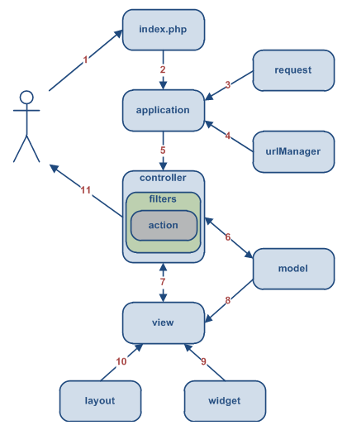
Figure 2.1.1.1. Typical workflow of a Yii application

- When someone visits the website "http://www.example.com/index.php?r=post/show&id=1," the web server receives their request and starts working by executing the bootstrap script "index.php."

- The purpose of this script is to set up the necessary tools and resources to handle the user's request. It creates an "Application" instance and runs it

- Inside this Application, there's a component called "request" that gathers all the important details about what the user wants.

- The application figures out which specific part of the website the user is looking for by using component called "urlManager,". In this case, the user is asking for something related to the "post" controller, which is a part of the website handled by the "PostController" class. Action the user wantts is "show," but the actual meaning is determined by controller.

- To handle the user's request, the application creates an instance of the "PostController." This controller knows that the user wants to see something related to the "show" action, so it looks for a method called "actionShow" inside its own class. But before executing that action, there might be certain checks or filters (like access control or performance measurement) that need to be carried out. These filters ensure that everything is in order and the action can be executed.

- Once the action begins, the controller goes to the database and retrieves a specific "Post" model that has an ID of 1. This model contains the relevant data that the user wants to see.

- After, the action needs to present this data to the user in a readable way. It does this by rendering a "view" called "show."

- The view takes the data from the Post model and displays its attributes.

- During this rendering process, the view may also incorporate certain widgets or additional elements to make the user experience better.

- Finally, the result of the view's rendering is placed within a predefined layout..

- When all these steps are complete, the action finishes its work and shows the result to the user.

Server and Clients

Web protocols

Web attacks and security

Practical part

The project idea
The main idea behind this project was to develop an Erasmus web application which helps the students of the universities of Split to find opportunities to study abroad and to connect with students who have same goals. The main focus is on using Yii2 framework and to have a foundation to evaluate its functionality and capability and to compare it in the theoretical part of this work with other PHP frameworks. The main parts of this application are the designing and development of the webpage as well as implementation of an SQL database holding the information of the user profiles and the Erasmus universities.

Setup

Yii2 project
The entry point of this project was the setup of the Yii project. The procedure was mainly to follow the “Getting started” section of the “The Definitive Guide to Yii 2.0” page (https://www.yiiframework.com/doc/guide/2.0/en). Because Yii is a PHP framework it uses the standard php package manager called Composer which was installed in the first place. The composer was then used to install all the required programs and assets as well as for the setup of the Yii2 project. The installation was at the end verified by executing the “php yii serve” command in the command line terminal and going to “http//localhost:8080” in the chrome web browser. Which would then display the homepage of the Yii 2 template that is shown in the following picture.

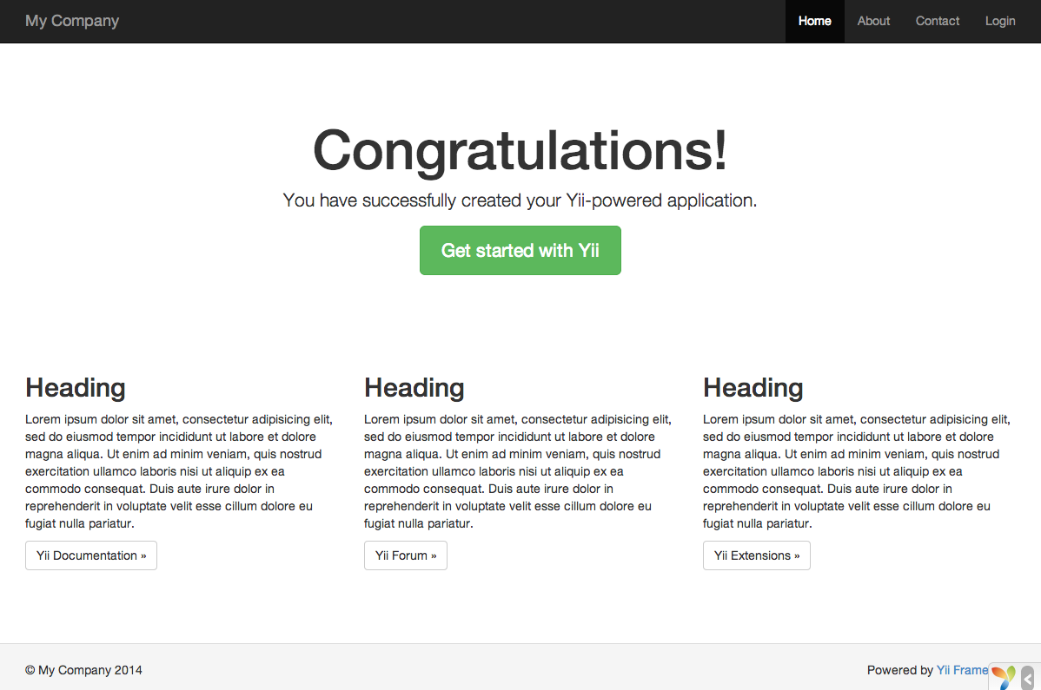
Figure 3.2.1. Hompage of Yii2 framework

The folder structure of the project looks as follows:

basic/ application base path
composer.json used by Composer, describes package information
config/ contains application and other configurations
console.php the console application configuration
web.php the Web application configuration
commands/ contains console command classes
controllers/ contains controller classes
models/ contains model classes
runtime/ contains files generated by Yii during runtime, such as logs and cache files
vendor/ contains the installed Composer packages, including the Yii framework itself
views/ contains view files
web/ application Web root, contains Web accessible files
assets/ contains published asset files (javascript and css) by Yii
index.php the entry (or bootstrap) script for the application
yii the Yii console command execution script

Web Server and SQL database
For the realization of the web server and the SQL database, the windows program XAMPP was chosen. XAMPP provides an apache server functionality on windows and may run a SQL database on it. After the installation, the server needs to be configured to be able to use Yii project web folder, as the root folder of the server, using the following configuration code snippet:

# Set document root to be "basic/web"
DocumentRoot "path/to/basic/web"

<Directory "path/to/basic/web">
# use mod_rewrite for pretty URL support
RewriteEngine on

# if $showScriptName is false in UrlManager, do not allow accessing URLs with script name
RewriteRule ^index.php/ - [L,R=404]

# If a directory or a file exists, use the request directly
RewriteCond %{REQUEST_FILENAME} !-f
RewriteCond %{REQUEST_FILENAME} !-d

# Otherwise forward the request to index.php
RewriteRule . index.php

# ...other settings...
</Directory>

From now on the web page can be accessed over the localhost url when the XAMPP server is running.
XAMPP offers also the possibility to run an SQL database on the same server. This data base was used to store the registration information of the users and to check them with the data on loign. For this the following table is used:
To do: Ad a register table picture and describe the columns.

The data collection of the universities offering Erasmus programs was stored in an excel file. This file had 16 different worksheets one for each university of Split. The chosen method to import the information into the data base consisted of the following steps:
- Prepare the Excel sheets for a valid export into .csv
- Check and fix findings in the csv file
- Import the csv data into the SQL server
The two main problems with the excel sheet were the inconsistency of the notation of different entries and the merged cells.
The merged-cells-problem was solved by the following approach. Firstly the following Visual Basic Script was found (here https://www.extendoffice.com/documents/excel/1139-excel-unmerge-cells-and-fill.html) and used to unmerge the cells and copy the values in al rows which would be empty after the unmerging.

Sub UnMergeSameCell()
'Upadateby Extendoffice
Dim rng As Range, xCell As Range
xTitleId = "KutoolsforExcel"
Set WorkRng = Application.Selection
Set WorkRng = Application.InputBox("Range", xTitleId, WorkRng.Address, Type:=8)
Application.ScreenUpdating = False
Application.DisplayAlerts = False
For Each rng In WorkRng
If rng.MergeCells Then
With rng.MergeArea
.UnMerge
.Formula = rng.Formula
End With
End If
Next
Application.DisplayAlerts = True
Application.ScreenUpdating = True
End Sub

The second script was used to merge two rows by appending the field of studies and the contact information of the rows which have identical other fields.
As a third step, the inconsistency had to be manually fixed because the rules and the mistakes were to complex to write a script for it.
In the next step each Excel worksheet was exported in a .csv file which then were merged into one. To make the database ready an ID column was added to be used as a primary key and the name of the home university was added corresponding to the data`s original datasheet name.
In the last step the csv file was importet over the phpaMyAdmin page into the SQL base.
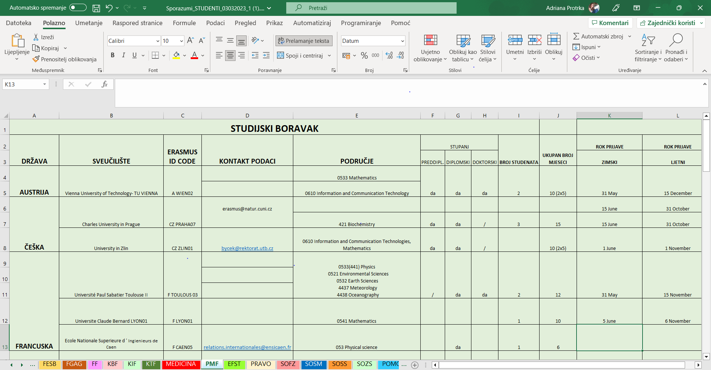
Figure 3.2.2.1. Raw excel file

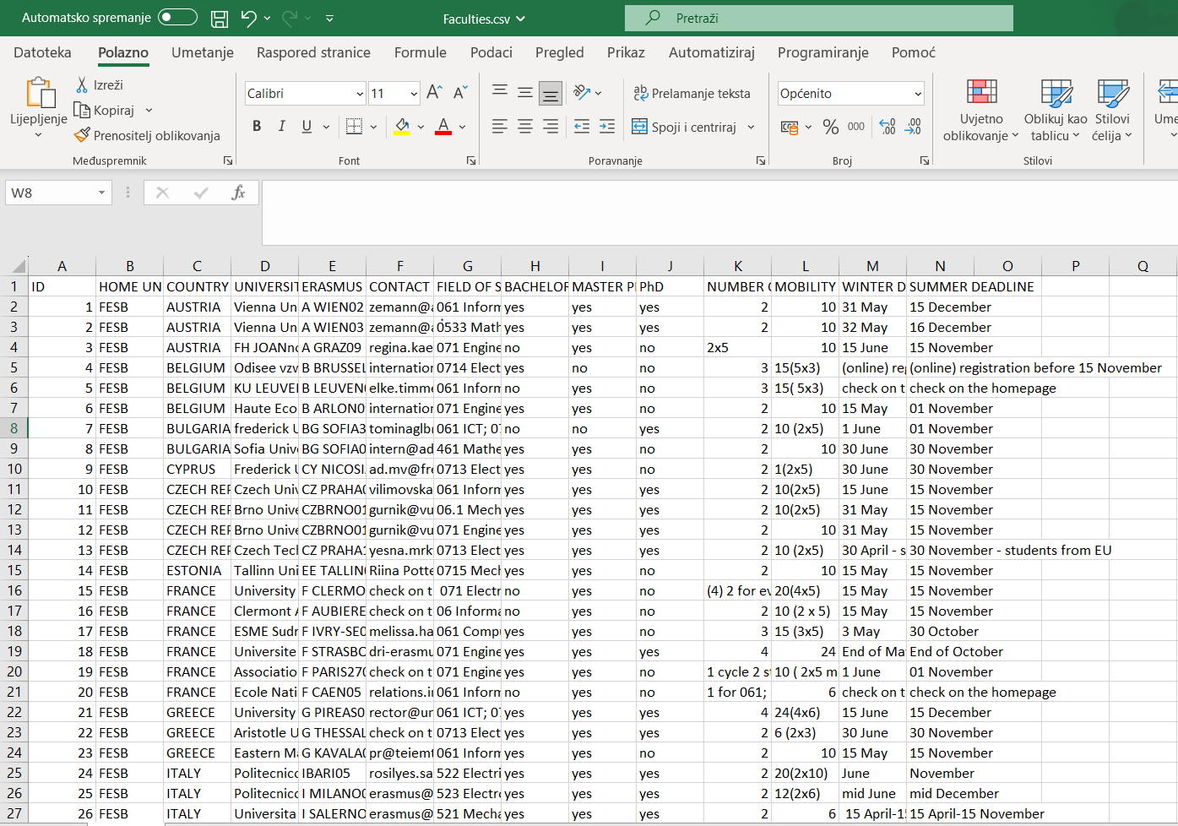
Figure 3.2.2.2. Processed .csv file

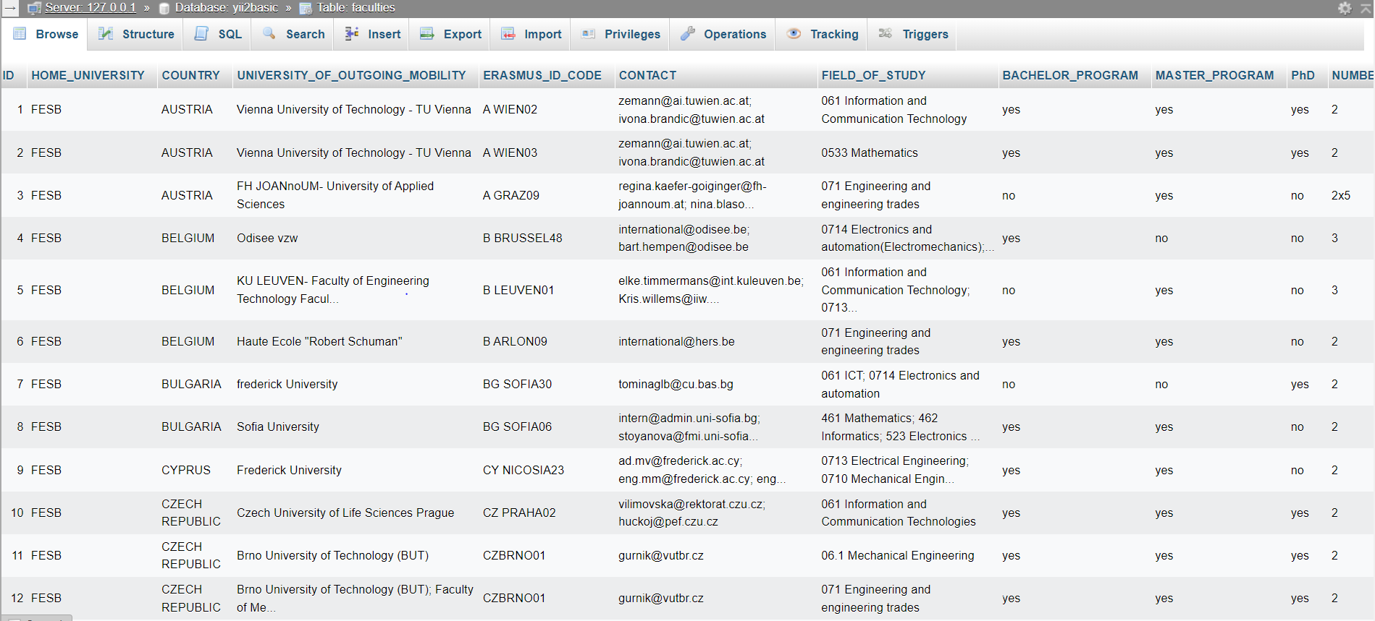
Figure 3.2.2.3. Database in phpMyAdmin

To do: Mention pictures in the text
To do: Describe columns of university table

Implementation and design

Result and discussion

Conclusion

